RESSAC
Case study: To provide a process for COTS AEH ready to apply Overarching Properties (OPs).
Domain: COTS AEH. Commercial Off-The-Shelf (COTS) Airborne Electronic Hardware (AEH).

Context and purpose: An expected target for RESSAC is to illustrate the Overarching Properties (OPs) and OP’s evaluation criteria (OPCs) with some representative use cases. COTS AEH are good candidates to quickly test an OP-based assurance approach without the need to refer to the whole set of processes, objectives, activities and data recommended by ED-80/ DO-254 for a developmental AEH.

COTS AEH life-cycle data are anyway not available per ED-80/DO-254, hence an alternative approach must be selected that will necessarily depart from a traditional structured development approach.

The purpose of this use case is to describe a more product-oriented approach including objectives on product attributes, related activities and evidence data that could be expected to be met, conducted and provided, respectively for a COTS AEH type. Such an approach will then be assessed with respect to the Overarching Properties (OPs) themselves and their OPs evaluation criteria currently established.

Context: In the framework of muXAV EPS system development, resources such as microcontroller are anticipated. As it is typically done within industry companies, an upfront activity is performed to be able to determine pre-evaluated microcontroller candidates that can fit both the product and project needs, together with the envisioned customer and certification requirements.

This present use case describes the process applied to select and collect associated data for a generic microcontroller solution that could be useful for the muXAV EPS implementation. It starts with a set of information and/or expectations coming from market and potential users. It stops before integration into the upper level hardware item intended for the users’ projects.

Expected benefits
- Establish the activities and artifacts necessary to handle assurance for a COTS AEH,
- Provide a description of a modified and/or new approach to COTS AEH assurance,
- COTS AEH process can be assessed via overarching properties and evaluation criteria).

Current standards issues: Applicable Industry Standard such as ED-80/DO-254 dated April 2000, section 11.2 on COTS, and guidance or Interpretative Material such as EASA Certification Memo SWCEH-001 Iss. 1 Rev. 1 dated 9th March 2012, chapter 9 on COTS have been used extensively.

Difficulties to apply those current Industry standards and Authorities’ certification material were:
- (1) ED-80/DO-254 provides only a few objectives for COTS, mainly based on traditional ones,
- (2) EASA CM SWCEH-001 provides dedicated objectives but without any justification/rationale,
- (3) Future AMC 20-152 on COTS AEH will also provide dedicated objectives for COTS AEH,
- (4) The OP’s approach is very promising in terms of streamlining the approach to assurance,
- (5) However a real application is necessary both to show how to proceed and what to modify,
- (6) COTS AEH are very different objects when compared to developmental hardware/software.

Compliance demonstration could be based on the following considerations:
The route to compliance for COTS AEH was until now based on objectives mandated by certification authorities that had to be met by the applicant. Such objectives addressed main certification aspects of Certification Specifications (e.g. intended function, environmental and safety targets in CS-25). Only available data from the COTS AEH supplier could be used to build such an expected assurance to a satisfactory level able to show documented evidence that the objectives were met.

Process description:

Life cycle overview

The following process consists in six main stages established as groupings of COTS AEH-related assurance activities. Note again that for a COTS AEH, no life-cycle process can be really identified as COTS AEH are not developed per se but procured already developed to COTS supplier own company processes, hence without DO-254 compatible life-cycle data.

- COTS AEH Identification of expected needs (Market Surveys, Product Policy constraints, Target Use Cases or Applications)
- COTS AEH Selection and evaluation of the supplier (Data/Documentation identification (datasheet, user’s manual, notes, Complexity Assessment Electronic Component Management Process definition, Capture and assessment of Errata (identification, analysis and workaround)
- COTS AEH Usage Domain Definition, Validation & Verification (forbidden use cases, worst case performance, etc. mitigation of effects of inadvertent activation of unused functions, monitoring of critical configuration settings, etc. Interface Requirements, Constraints (HSI, HHI, etc.)
- COTS AEH Functional Failure Path Analysis (FFPA) or Functional FMEA, particularly for DAL A & B
- COTS AEH Continued configuration management follow up (errata and change analysis, maturity, service history)
- COTS AEH Integration, Validation & Verification, and Qualification to environment: This stage is usually combined with a CBA/LRU-level development process

The first figure below illustrates what are the main processes (Design, Verify and Operate) that are aimed at when dealing with incorporation of COTS AEH into an hardware design.

The second figure illustrates how a COTS AEH is always embedded within some other encompassing electronic hardware item, e.g.: A Circuit Board Assembly (CBA) or product.

The process described in this use case covers only the parts circled in red. The integration process into an encompassing product might be described in another use case.

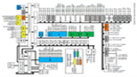
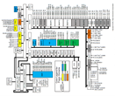
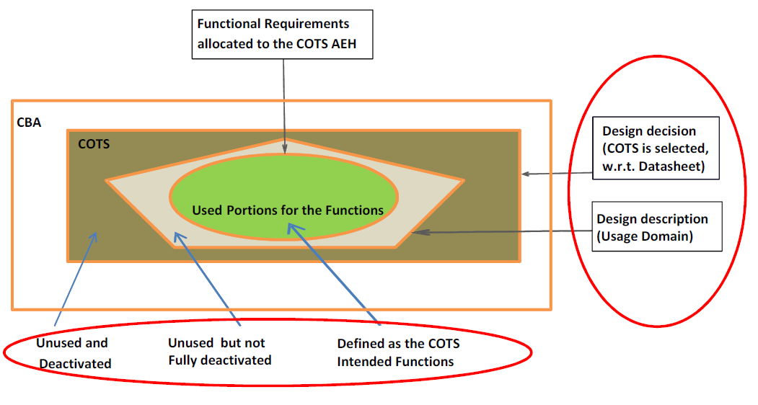
CBA
COTS
I
O
DESIGN
Induction (Intended Output): Designing AEH using the COTS
CBA
COTS
I
O
OPERATE
Deduction (Cause-to-Effect): Operating AEH incl. the COTS
CBA
COTS
I
O
VERIFY
Verification (Expected Output): Verifying AEH with the COTS
Expected Function(s)
OK

The followings address all six stages or sub-processes defined above along with the items of:
- Inputs,
- Outputs,
- Method and environment:
- Responsibility:
- Description:
- Errors sources and classes
- Means to address error sources and classes

- COTS AEH Identification of expected needs and behaviors

Input data:
- Product market data
- Components technology data

Inputs used for process activity:
- Market and technology surveys,
- Internal R&T review results, including company Product Policy strategy,
- End-user and project feedback, including foreseeable operating and environmental conditions.

Outputs:
- Expected needs and behavior, including allocated Safety and DAL objectives
- H/W – H/W and H/W – S/W interfaces (if any)
- List of preselected COTS AEH devices and suppliers.

Methods & environment:
Market Surveys, including competition and specialized publications

Responsibility: R&T experts, together with:
- Marketing experts,
- Product policy manager,
- Technology experts, and
- Miscellaneous other stakeholders

Description: The purpose of this activity is to identify the expected needs that the COTS AEH will be destined to fulfill. This is based on one hand on product market survey to determine which applications are targeted, and on the other hand on state-of-the-art technology survey to determine the candidates COTS AEH suppliers and components.
A pre-selection is provided to limit the subsequent activities.
A Target DAL level is also provided (from the expected applications types)

Errors sources and classes:
The expected needs are not correctly identified (too wide or too narrow or wrong target)

Means to address errors sources:
Lessons learned on projects and feedback from end-users.

- COTS AEH Selection and evaluation of the supplier

Input data (mainly the output from the previous stage):
- Expected needs and behavior, including DAL objectives
- List of preselected COTS AEH devices and suppliers.

Inputs used for process activity:
- ECMP (Guidance, Standards, Criteria).
- COTS Suppliers more detailed data
- Foreseeable operating conditions

Outputs:
- COTS AEH Device Data/Documentation from COTS Supplier (datasheet, user’s manual, application notes, errata list, etc.)
- COTS AEH Electronic Component Management Report (ECMR) including COTS characteristics and performance, evidence of analyses and Audits results.
- COTS AEH Device and Supplier(s) selected pair(s).

Methods & environment:
- Reviews and Analyses of COTS AEH suppliers’ data
- Engineering Assessment vs expected needs & behaviors
- Audits questionnaires.

Responsibility:
Technical expert team supported by other specialties (quality, certification, safety, etc.)

Description:
The purpose of this activity is to select a COTS AEH Supplier-Device pair able to meet both the applications needs and to determine acceptable maturity of the technology, e.g. to TRL 5.

Rationale for this selection is provided in a first issue of the Generic ECMR. This should include the rationales to select such component and evidences that contribute to provide an acceptable level of confidence and level of maturity of the COTS.

The selected COTS AEH should also be able to be mastered by designers (e.g. dispositions to control deterministic behavior are defined)

One of the outputs is also a set of trusted documentation (from COTS AEH provider) that can be used for the subsequent activities (and also by the end-user project in charge of COTS usage). This documentation is managed under configuration.COTS device errata list (from COTS provider) is also available and managed under configuration.

Errors sources and classes:
- The COTS AEH selection does not fit the expected needs.
- The selected COTS AEH is too complex
- The COTS is too immature to be handled properly and safely.
- The COTS AEH has too many residual design errors revealed or not by errata.
- The COTS AEH datasheet is not consistent with the actual device or is incomplete (e.g. not documented) or incorrect.
- Potential inadvertent activation of hidden functions (not documented) during use of the component.

Means to address errors sources:
The whole purpose of selection and evaluation is destined to avoid such errors.
- A/ and B/ Selection result is reviewed by stakeholders (sponsors, end_users, program manager) before final decision (could be a final presentation for decision)
- C/, D/ and E/ This COTS will not be selected (no go decision)
- F/ COTS provider choice and service history to minimize this risk, associated to a safety analysis that take this never-closed point in account.

- COTS AEH Usage Domain identification

Input data:
- COTS AEH datasheet, application notes, expected needs/behavior
- Specific ECMR for the selected COTS AEH

Inputs used for process activity:
- Errata list
- Foreseeable operating conditions (Prototype bench, Model, Evaluation board)

Outputs:
- Updated generic ECMR, including identification of the COTS Usage Domain limitations, Usable list of functions and associated errata analysis,
- Unused functions mitigation (deactivation/monitoring), including recommended configuration settings and errata suggested workarounds,
- Potential acceptable uprating and mandatory associated process,
- Interface constraints (HIS, HHI) and limitations.

Methods & environment:
- Reviews (e.g. Validation review of the Usage Domain),
- Analyses of te COST AEH documentation and
- Testing using a prototype bench,

Responsibility:
Technical expert team,
System expert
Safety expert

Description: The purpose of this activity is to determine how the COTS AEH device functions can be used (configured) to meet both the needs and correctly implement a COTS AEH technically suitable for operation.
At the level of this process, the end-user of the COTSA EH is still not present. Consequently this activity is limited to some prescriptive recommendations. A complement of activity should be performed by end-user to have a final view about the COTS usage.

This includes:
- Identification of usable/non-usable functions,
- Analysis of related errata and suggest workarounds,
- Determine appropriate configuration settings,
- Solution for inhibition/monitoring of unused functions,
- Solution for inadvertent loss of critical configuration setting,
- Determine authorized uprating parameters and associated process,
- List of interface requirements and constraints in HSI and HHI.

All these data can be the output of analysis of COTS AEH available documentation.
It can be also the result of a prototyping activity (based on evaluation board, test vehicle, first user project) in case of complex usage or/and in case of detected lack of internal maturity in usage of such type of component (TRL).

Errors sources and classes:
- COTS AEH used outside its allowed domain in terms of characteristics, performance or interfaces.
- Activities did not properly identified usable/non usable functions, known errata, appropriate configuration settings, uprating limits, etc.

Means to address errors sources:
- Independent review of the completed ECMR and associated evidences.
- Prototyping activity if necessary to limit the error risk

- COTS AEH Functional Failure Path Analysis (FFPA)

Input Data:
- Functional Block description of used functions in the COTS AEH,
- Allocated/Assumed Safety, Failure Conditions (FC) and DAL,
- Errata impact analysis and mitigation/workarounds.

Inputs used for process activity:
- Potential usage domain (from generic ECMR).
- Procedures, guidance, checklists to conduct FFPA,
- Foreseeable operating conditions (functional versus dysfunctional operation).

Outputs:
- Functional failures paths analysis (FFPA) at the COTS AEH level for used configuration,
- Capture, assessment and mitigation of relevant errata and their impact on safety,
- Identification of critical failures situations: errors in settings, un-mitigated errata, etc.

Methods & environment:
Safety-specific analyses, FFMEA/FFPA Tools

Responsibility:
FFMEA expert

Description: The purpose of this activity is to assess the dysfunctional behavior of the COTS AEH device on the basis of a first level of functional block diagram available and the identified failure conditions. This can be done first of all qualitatively, then quantitatively if failure data is available.

Note: Result of this activity may impact all the previous activities (expected behavior, usage domain, limitations, COTS selection)

Errors sources and classes:
- Lowered safety impact of COTS usage
- Missed some critical paths

Means to address errors sources:
Close relationship with trustable COTS provider in order to complete available data (e.g. information on actual architecture, memory protection mechanism)

- COTS AEH Continuous Management

Similar to “COTS AEH Selection and evaluation” activity (Stage 2) but performed as part of a continued airworthiness activity

This activity is out of the scope of a product or system development.
However, in the frame of a process oriented assurance demonstration, it could be of interest to provide a process that guarantee the sustainability and the reproducibility of COTS usage during all the life of the product (e.g. errata are assessed not only during design, but are continuously assessed)

This stage should also incorporate miscellaneous activities related to the COTS AEH, e.g. configuration management, process assurance, certification liaison.

And post-TC:
- Continued assessment of relevant and new errata and impact on safety,
- Identification of the safety impact & effects of COTS failures and defects,
- Change management incl. Problem Reporting & Change Impact Analysis.

- COTS AEH Integration and verification

Performed as part of CBA/LRU (product) development process
Generic ECMR (including usage domain recommendations), available documentation, additional data from provider are considered as inputs for the end-user projects that decide to implement this suggested COTS as a solution to some system requirements.

This stage should also incorporate miscellaneous activities related to the COTS AEH:
- Verification of COTS Usage Domain vs allocated requirements,
- Verification of technical suitability in general (e.g. performance, robustness),
- Verification of H/W-H/W and H/W-S/W Interfaces (if any),
- Functional Verification (at LRU level),
- Environmental Qualification (LRU level),
- Acceptance Verification (at LRU level, particularly for safety mechanisms).

Artefacts examples:

Miscellaneous artifacts are used when applying OPs. For a COTS AEH such artifacts are produced as a result of adequate activities.

